**EXPERIMENT-1**

**Configuration of Network Devices using Packet Tracer (Hub, Switch, Ethernet, Broadcast)**

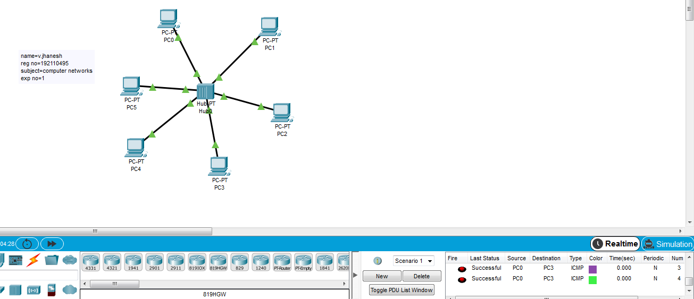

**EXPERIMENT-2**

**Configuration of Topologies using Packet Tracer (Star, Mesh, Tree,)**

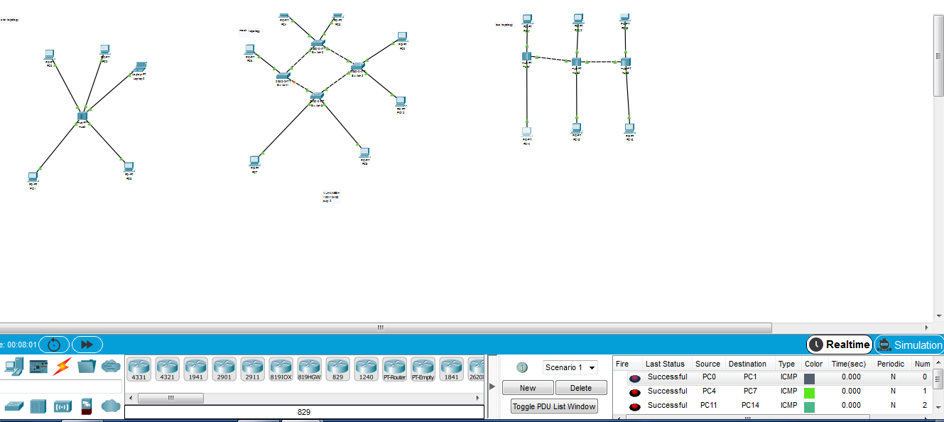

**EXPERIMENT-3**

**Configuration of Topologies using Packet Tracer (Bus, Ring, Hybrid)**

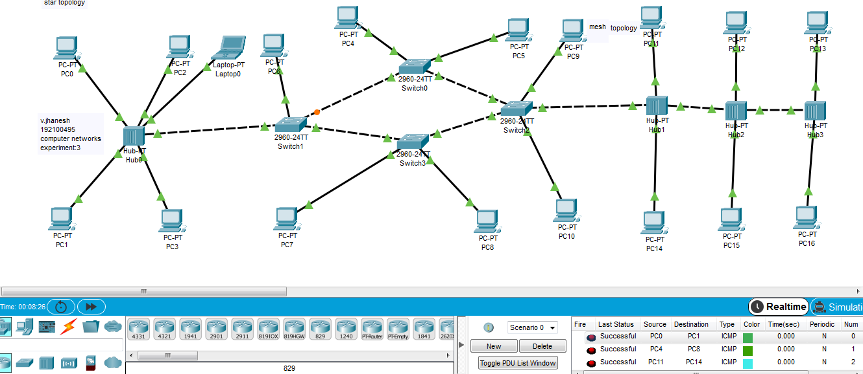

**EXPERIMENT-4**

**Data Link Layer Traffic Simulation using Packet Tracer Analysis of ARP**

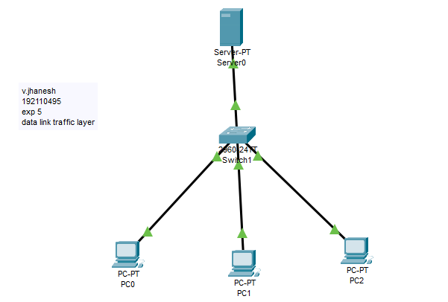

**EXPERIMENT-5**

**Data Link Layer Traffic Simulation using Packet Tracer Analysis of CSMA/CD& CSMA/CA**

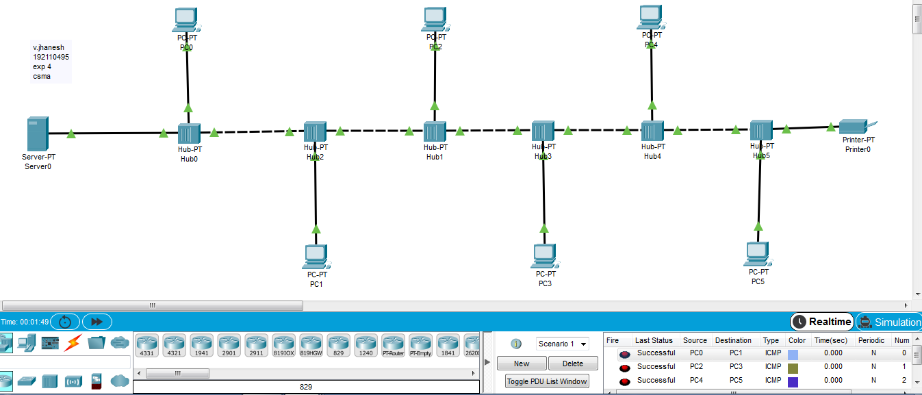

**EXPERIMENT-6**

**Static Routing using Packet Tracer**

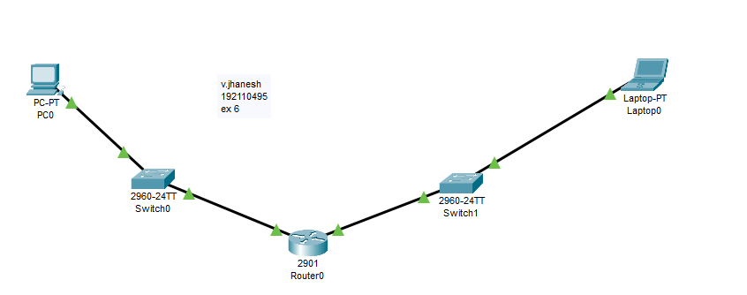

**EXPERIMENT-7**

**Dynamic Routing using Packet Tracer ( OSPF)**

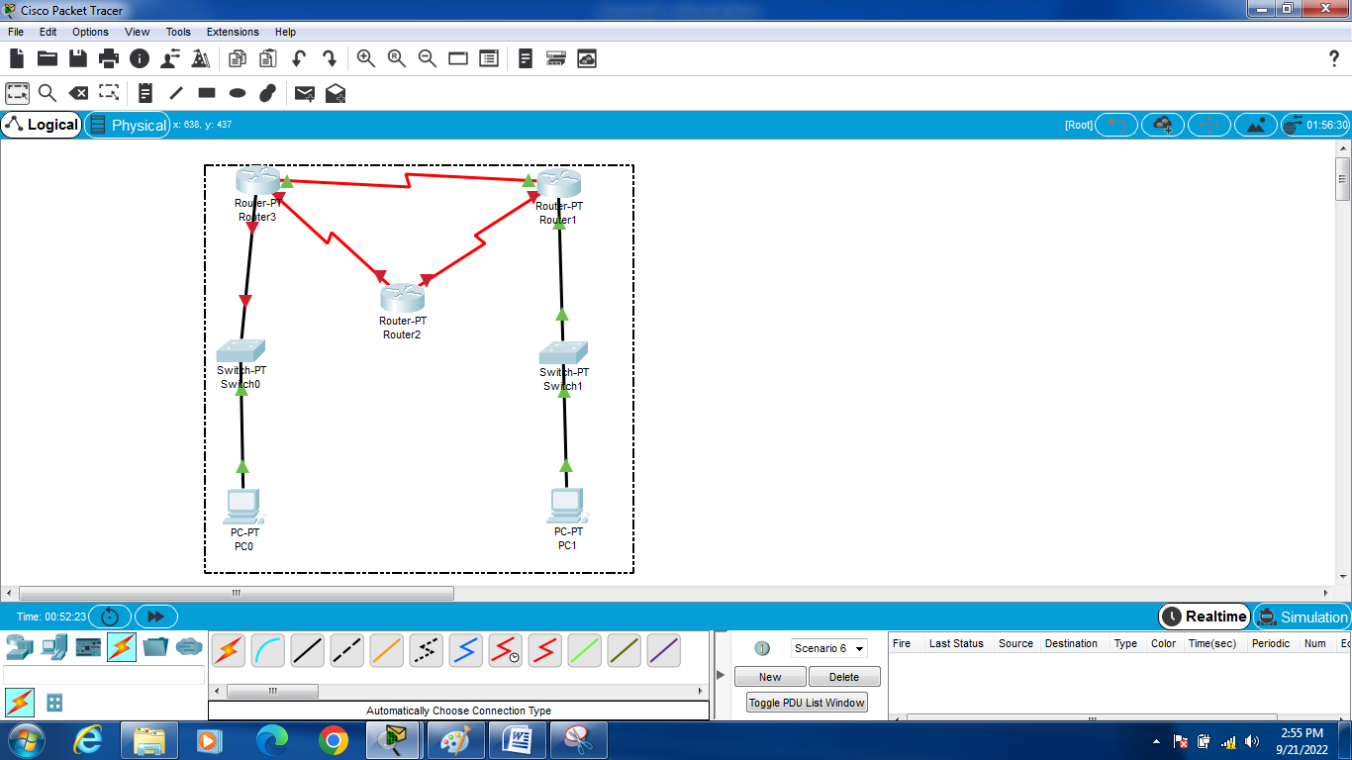

**EXPERIMENT-8**

**Functionalities of TCP, UDP**

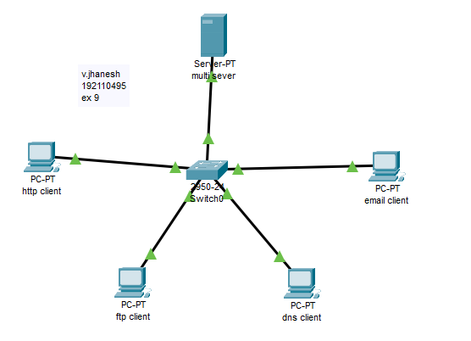

**EXPERIMENT-9**

**TCP, UDP Exploration Solution**

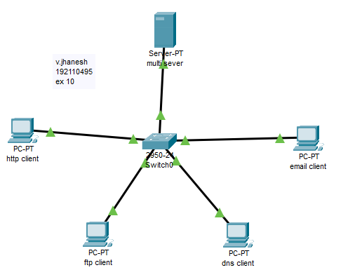

**EXPERIMENT-10**

**Subnetting–ClassCAddressing**

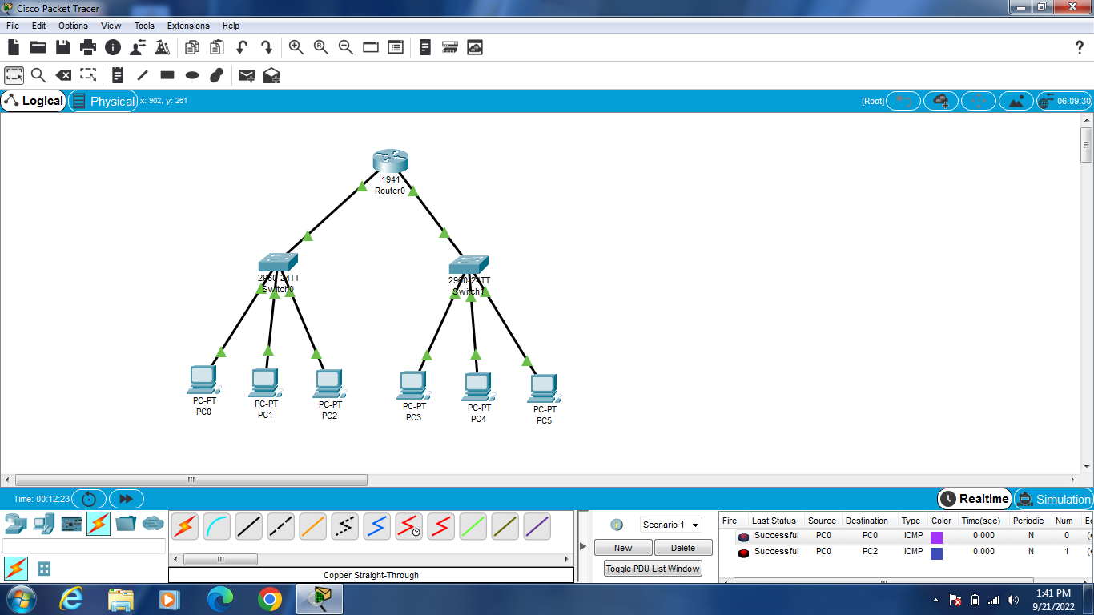

**EXPERIMENT-11**

**SIMULATING X,Y,Z COMPANY NETWORK DESIGN**

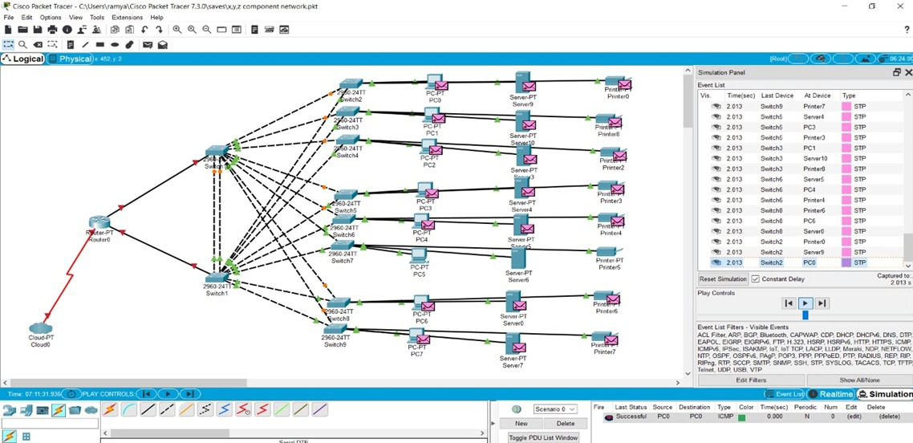

**EXPERIMENT-12**

**Smart Garden in Cisco Packet Tracer**

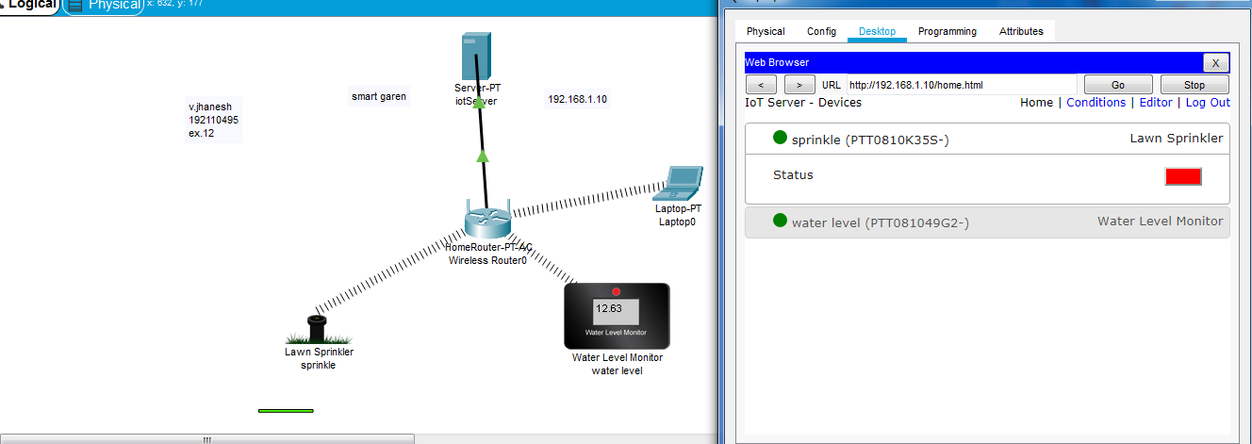

**EXPERIMENT-13**

**IOT Devices in Networking Using Cisco Packet Tracer**

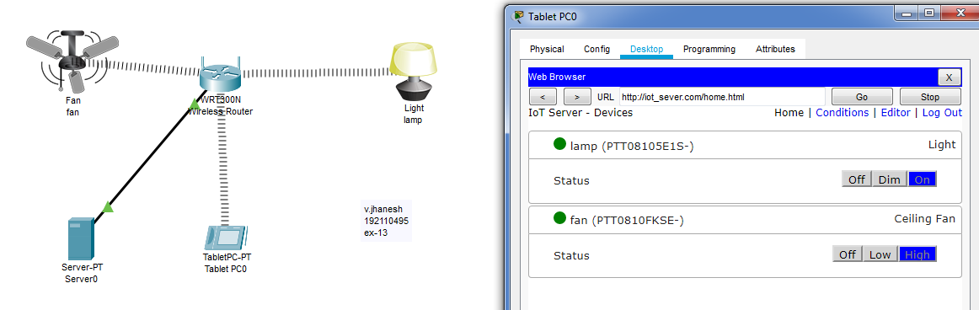

**EXPRIMENT-14**

**IOT Based Smart Home Using Cisco Packet Tracer**

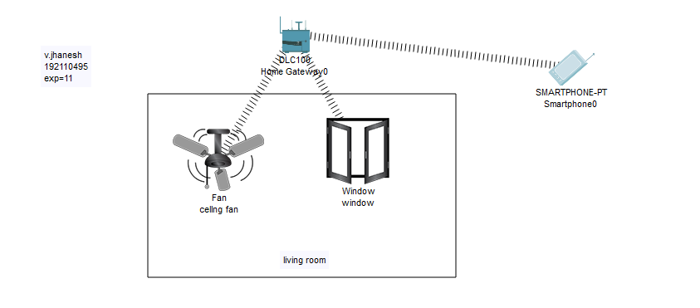

**EXPERIMENT-15**

**MAKE COMPUTER LAB IN CISCO PACKET TRACER**

